**Report on Predictive Modeling for Ontario Wells Depth (2024)**

**Introduction**

The objective of this project was to develop predictive models for estimating the depths of wells in Ontario, Canada, using three different techniques: Inverse Distance Weighting (IDW), Kriging, and Kriging Model 2. This report outlines the methodology, data preprocessing, model implementation, evaluation metrics, and visualizations of the results, along with insights gained during the project.

**Data Collection and Preprocessing**

The dataset utilized for this study comprises well data from Ontario, including features such as geographic coordinates and recorded depths. The following steps were performed to prepare the data for analysis:

1. **Source of Data:**

The dataset comprised well logs from Ontario, including spatial coordinates (latitude and longitude) and well depths. These records provided the foundation for spatial interpolation techniques

**2. Data Cleaning:**

* + Removal of missing or inconsistent entries.
  + Verification of coordinate accuracy to ensure correct spatial referencing.

**3. Standardization:**

* + The well depth values were standardized to ensure comparability across different models and to reduce the impact of outliers.

**4. Exploratory Data Analysis (EDA):**

* + Summary statistics and visualizations were generated to understand the distribution of well depths and to identify patterns in the spatial data.
  + Moran's I statistic was calculated to assess spatial autocorrelation, confirming the appropriateness of geostatistical methods such as Kriging.

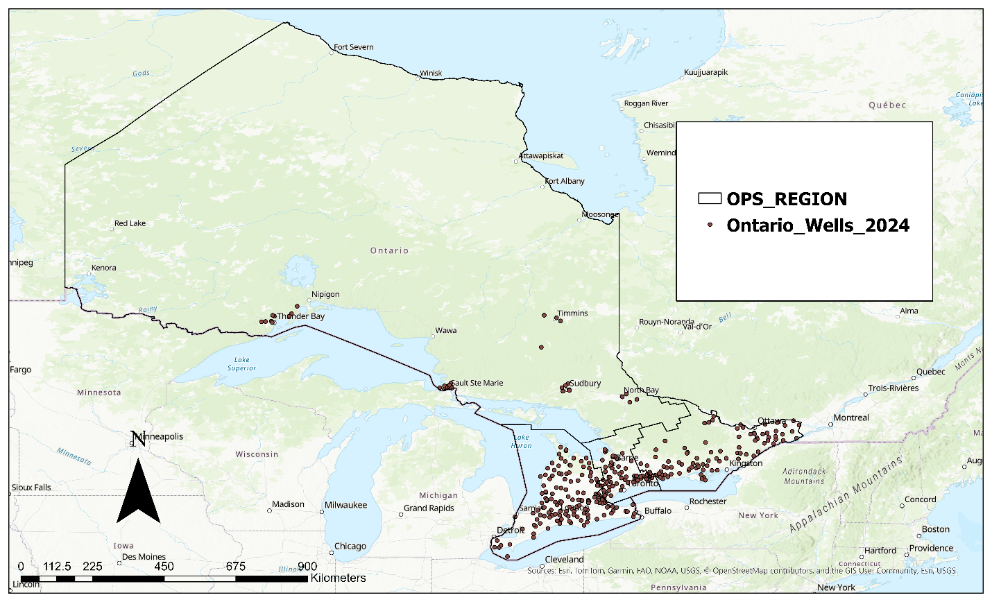

Figure 1. Map showing the Ontario Wells Distribution for the year 2024

Performing a spatial correlation analysis on the Ontario well distribution shows that;

Given the z-score of 4.092423, there is a less than 1% likelihood that this clustered pattern could be the result of random chance.

**Predictive Techniques**

1. **Inverse Distance Weighting (IDW):**

IDW is a deterministic interpolation method that estimates unknown values based on the weighted average of nearby known values, with weights inversely proportional to distance IDW assumes that points closer to the target location have more influence on the prediction than those farther away.

A power parameter was optimized to determine the best weight distribution. The parameters for the IDW technique are show below:

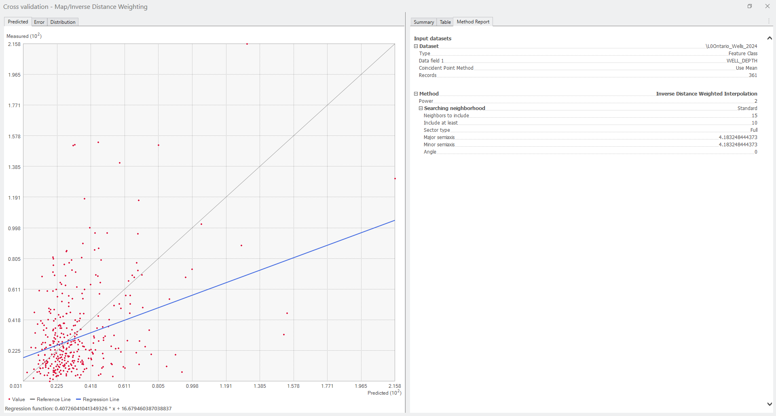

The result of the IDW analysis gives the result:

1. **Kriging (Ordinary Kriging):**

Kriging is a geostatistical method that considers both the distance and the degree of variation between known data points.

This geostatistical method models the spatial autocorrelation in the data. A semivariogram was constructed to describe the spatial relationship between points, and parameters (range, sill, nugget) were estimated.

1. **Kriging Model 2(Enhanced Kriging):**

This variant of Kriging incorporated additional refinements in semivariogram fitting, including automated parameter optimization and cross-validation. Enhanced Kriging model with additional refinements in the semivariogram fitting process.

Different variogram models (e.g., spherical, exponential) were tested to select the best fit for the data.

**Results and Visualizations**

1. **Box Plot Analysis:**

A comparative box plot of standardized well depths and predictions from IDW, Kriging, and Kriging Model 2 revealed the distribution and variance of the predictions relative to the actual data.

From the result below the IDW exhibited the least variance and closest alignment with observed values.

1. **Scatter Plot Analysis:**

Scatter plots were created to examine the relationships between observed and predicted depths for each model.

Idw prediction displayed tighter clustering around the line of equality compared to Kriging and Kriging 2, indicating better performance.

**Limitations:**

* + Sparse data points in some regions may reduce the accuracy of predictions.
  + Assumptions of stationarity in Kriging may not fully capture spatial heterogeneity.

**Conclusion and Recommendations**

The project demonstrated that geostatistical models, particularly Kriging Model 2, are well-suited for predicting well depths in Ontario. Future work could explore:

* Incorporating additional covariates (e.g., geological features).
* Using machine learning methods for comparison with geostatistical approaches.
* Increasing data density in underrepresented areas to improve prediction accuracy.